**ESMS – Annex 7**

**Guideline for the Submission of a Proposal to the**

**Alliance for a Green Revolution in Africa (AGRA)**

*GUIDELINES FOR SUBMITTING A PROPOSAL TO*

*THE ALLIANCE FOR A GREEN REVOLUTION IN AFRICA (AGRA)*

*You are kindly advised to adhere to these guidelines to facilitate processing of your proposal.*

***Proposal Template***

Please submit all materials in English:

1. **PRE-AWARD ASSESSMENT DOCUMENTS**

* Provide a brief description of the institution and the implementing unit including its mandate, when it was formed, status, and the locations at which it operates. Provide a brief narrative description of (i) your organization's principal purpose or mission, (ii) the activities and operations presently carried on by your organization, and (iii) those activities that you intend to carry on in the future.
* Attach a copy of your organization's charter, bylaws, and any other documents, in­cluding any relevant statutory laws, pursuant to which your organization was formed or by which its operations are governed.
* Provide a list of your organization's governing board and key officers.
* Provide latest audited accounts of your organization
* Provide a description of recent grants made by other organizations or units of government to your organization.
* Include a signed copy of the pre-grant inquiry form (see annex I below).

1. **COVER LETTER**

This letter must be on the applicants’ organization letterhead and signed by the head of the institution, his/her designee authorized official. It should include the following details:

* A short description of the intervention; including the methodology, number of targeted beneficiaries, duration of the grant, proposed start date, total budget estimate and requested amount.
* A short description of the grantee history or the consortia make up (as applicable).

1. **PAST PERFORMANCE (For organizations that have previously received grants from AGRA)**

* Describe the grant no(s).
* Total grant amount (include total of all grants received at the point of application)
* Duration of the grant
* Key objectives of the proposal and the overall performance
* Key information on the implementation of the Environmental and Social Action Plan

**Table 1: Summary of Deliverables against Targets**

| **Key Objective** | **Indicator** | **Targets** | **Achievement** | **% Achieved** |
| --- | --- | --- | --- | --- |
|  |  |  |  |  |
|  |  |  |  |  |
|  |  |  |  |  |
|  |  |  |  |  |
|  |  |  |  |  |

1. **GRANT PROPOSAL**

**Please provide a proposal executive summary that will include the following:**

* Name of institution(s) requesting funds
* Name, address, telephone, fax and e-mail of contact person, chief executive officer and financial officer at institution. ( if a consortia, this information is to be provided of all partners as appendices)
* Project Title
* Problem to be addressed
* Goal
* Main outputs and expected outcomes
* Key E&S risks to be managed throughout project implementation
* Number of targeted beneficiaries (specify direct and indirect).
* Total project budget amount.
* Amount requested (from AGRA) for the project.
* Other collaborating institutions, if applicable.
* Additional funding for this project requested/obtained from other organizations
* Proposed start date of project
* Duration of project

**TABLE OF CONTENTS**

Provide a list of sections and page numbers for easy reference by the reader.

**DETAILED PROPOSAL**

**Statement of the Problem**

* Describe the nature (what, why, when) and dimensions (geography and numbers of people affected) of the problem being addressed.
* Demonstrate its importance for poor and vulnerable households.
* Describe current status of work on this problem.
* Justification for the intervention.
* Note that quantitative data is very important.

**Strategy Proposed to Solve the Problem:**

* Describe the most promising opportunities to solve the problem, specify those chosen in this project, and explain the choice.
* Describe the overall strategy to be used in this project.
* Describe past work of the grantee institution in this problem area and the stage of initiation of this project. (Attach an appendix if multiple organizations are involved).
* Describe the framework including stakeholder and gender analysis.
* Describe the intervention(s) indicating targeted beneficiaries, projected yield, projected income per farmer, impact on women and youth and the methodology.

**Value for Money Statement**

* Describe how the intervention will leverage on other resources in the area of intervention and how this can scale up.
* Describe other institutions (public, private, national, regional or international) with which the grantee institution will collaborate to implement this project (who, where, their mandate and core competencies).
* Describe the nature of the collaboration (who will do what).
* For linkages with the private sector, describe in more detail the structure of the sector, the main actors, the main partner companies, and any special arrangements governing collaboration (licensing arrangements, etc.)

**Results Framework**

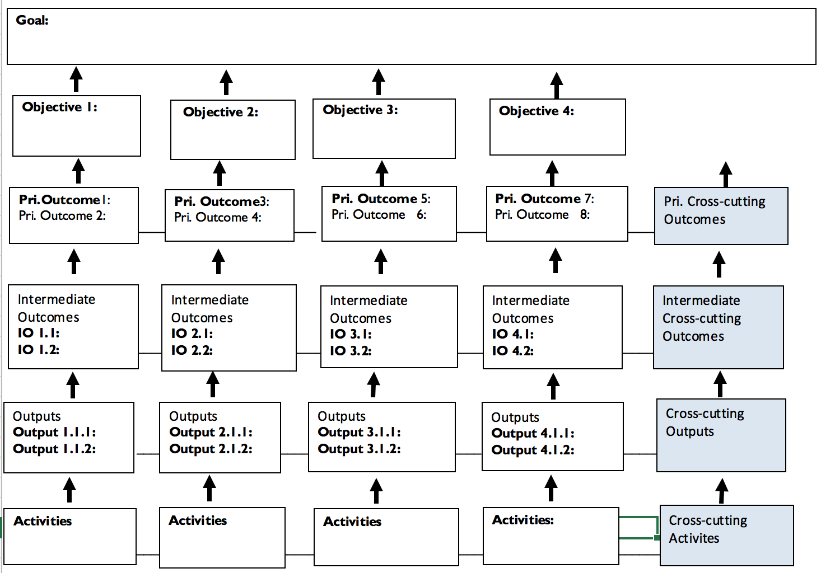

**Key Performance Indicators**

**Table 2: Key Performance Indicator Table**



**Project Implementation Plan (PIP):**

A project implementation plan must be developed in the AGRA PIP design and submitted with the proposal.

**Risk Management Plan**

Indicate the basic risks and assumptions that will affect the success of the project. A risk management framework must be completed using AGRA template.

This includes the management of E&S risks as per the below (please attach the Action Plan as a separate Annex to the risk management framework):

* Describe the main E&S risks expected during the project
* Provide an Environmental and Social Action Plan that details the measures how to manage the E&S risks throughout project implementation, key deadlines for implementation, responsibilities of the grantee/individual consortium partners and Key Performance Indicators for monitoring E&S performance. This draft ESAP should be based on Annex 13 to the AGRA ESMS.
  1. **Knowledge Management**

Knowledge management (KM) is important for organizational learning about what works and what does not work in agriculture and for supporting scaling and replication of successful interventions and avoiding mistakes of failed interventions. Knowledge captured from your project will also be useful for informing and influencing AGRA and stakeholders’ strategy and investment decisions. Examples of knowledge products include lesson learnt document, manuals or guidelines, technical project reports, publications, documentaries, impact studies, surveys and analysis among others.

Indicate the knowledge products to be developed over the life of the project.

|  |  |  |  |  |
| --- | --- | --- | --- | --- |
| **Product** | **Responsible** | **Frequency** | **Dissemination** | **Audience** |
|  |  |  |  |  |
|  |  |  |  |  |
|  |  |  |  |  |
|  |  |  |  |  |
|  |  |  |  |  |
|  |  |  |  |  |

**5. BUDGET (IN US DOLLARS)**

A summary budget per broken down per budget line items, detailed budget showing how the cost per budget line item was arrived at and explanatory budget notes on the detailed budget required. It is necessary to ensure the following:

* That the budget represents the work described in proposal and it should follow the activity based budgeting model.
* That the budget sub-components add up
* That annual budgets are available if grant is for multi-year.
* Provide AGRA prescribed disbursement plans.
* That the budget is denominated in U.S. dollar. Where local currency is used then the details of exchange rate and date of conversion should be provided.
* That AGRA policies on cost allowed and apportionments are understood and applied in the budgeting process (indirect costs policy, CAPEX policy, Overheads policy).
* Costs share (matching) related to for profit businesses should not be less than 10% of the entire project budget.

6. **PROJECT SUSTAINABILITY/TRANSITION or EXIT STRATEGY**

Provide a specific sustainability plan to show how the organization will manage activities as a going concern after AGRA’s support.

**7. MONITORING AND EVALUATION**

Provide a brief description of the project monitoring and evaluation plans to be used in the implementation of the project

**8. OTHER CONTRIBUTORS TO THE PROJECT**

Describe contributions (salaries, infrastructure, administrative support, etc.) to this project from other sources (government, other donors, non-governmental organizations).

**9. ALL PROJECT STAFFING**

|  |  |  |  |  |
| --- | --- | --- | --- | --- |
| **Names** | **Institution** | **Discipline** | **Education Qualifications** | **Time devoted to the project (%)** |
|  |  |  |  |  |
|  |  |  |  |  |

**10. KEY PROJECT STAFF(S)**

Provide the CV’s of key project staff who will contribute above 50% of their time to the project